
NAME : SABITHASRI B
REGISTER NUMBER : 732924CSR133
COURSE CODE : 22CST41
COURSE TITLE : DATABASE MANAGEMENT
SYSTEM
ASSIGNMENT TITLE : ASSIGNMENT_3 - SQL
QUERY PRACTICE

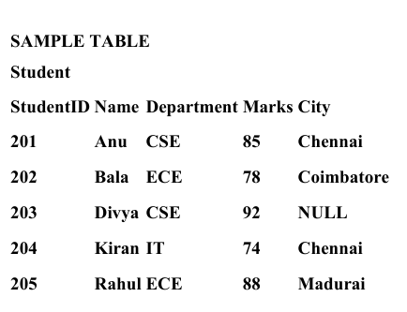
- Write an SQL query to display all student records from the Student table.
CREATE TABLE Sabithasri (
StudentID INT PRIMARY KEY,
Name VARCHAR(50),
Department VARCHAR(10),
Marks INT,
City VARCHAR(50)
);
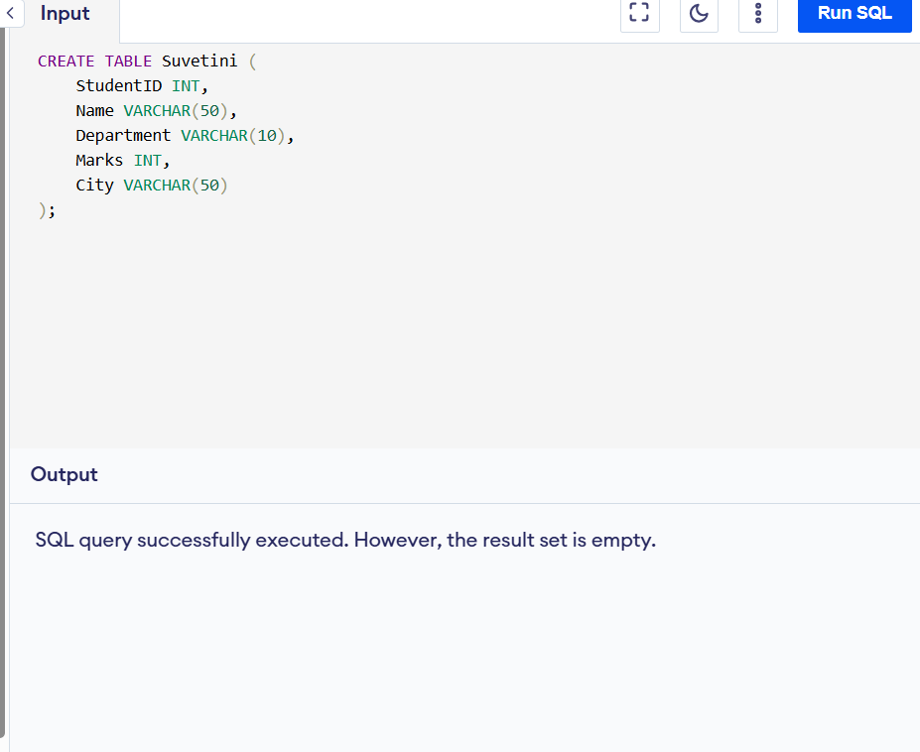
INSERT INTO Sabithasri VALUES (201,'Anu','CSE',85,'Chennai');
INSERT INTO Sabithasri VALUES (202,'Bala','ECE',78,'Coimbatore');
INSERT INTO Sabithasri VALUES (203,'Divya','CSE',92,NULL);
INSERT INTO Sabithasri VALUES (204,'Kiran','IT',74,'Chennai');
INSERT INTO Sabithasri VALUES (205,'Rahul','ECE',88,'Madurai');
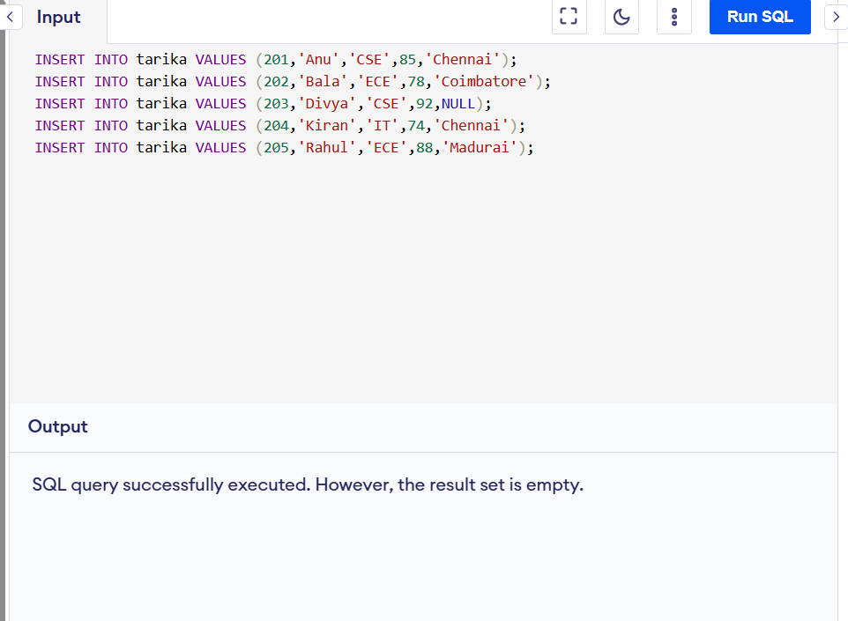
SELECT * FROM Student;
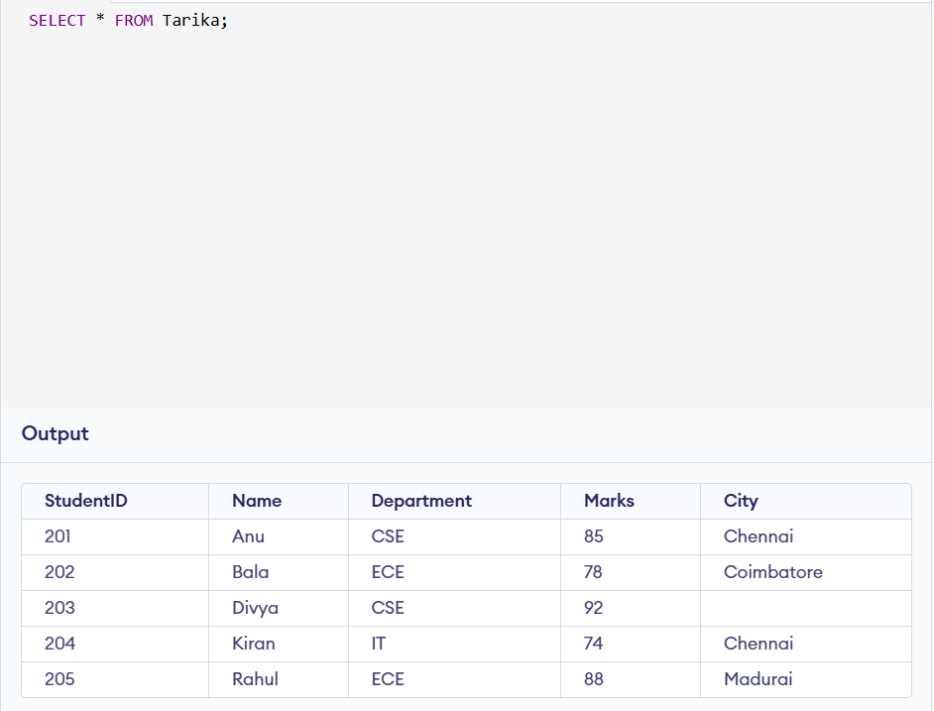

- Write a query to display the Name and Marks of all students.
SELECT Name, Marks FROM Sabithasri;
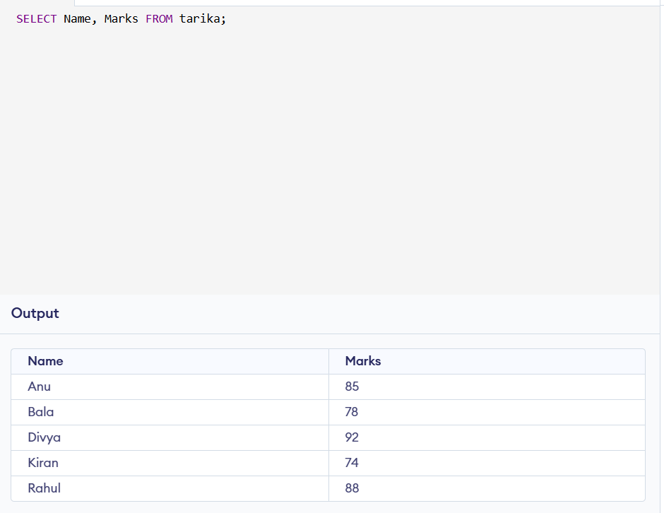

Write a query to display students who scored more than 80 marks.

SELECT * FROM Sabithasri
WHERE Marks > 80;
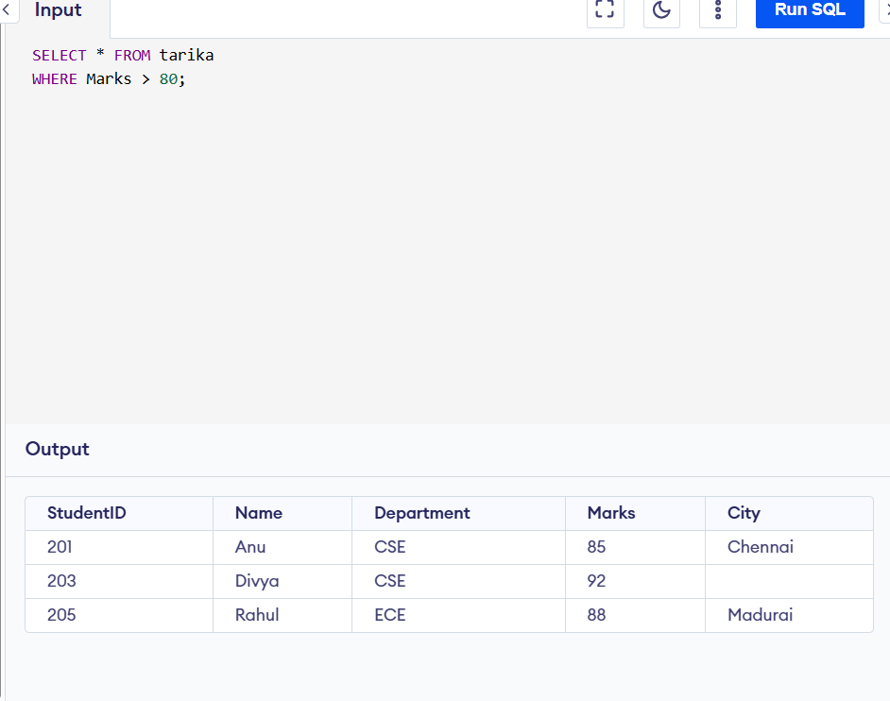

Write a query to display students belonging to the CSE department.
SELECT * FROM Sabithasri
WHERE Department = 'CSE';
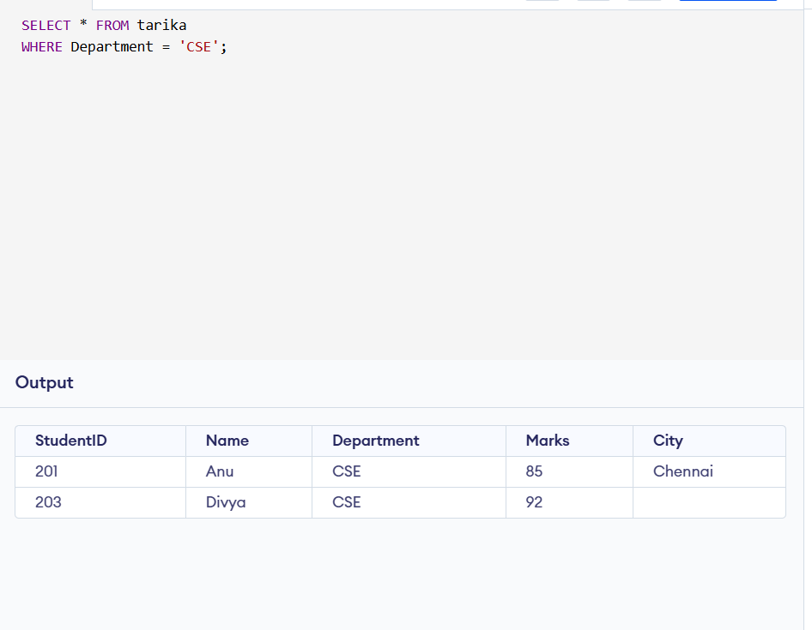
- write a query to display students whose city is Chennai.
SELECT * FROM Sabithasri WHERE City = 'Chennai';
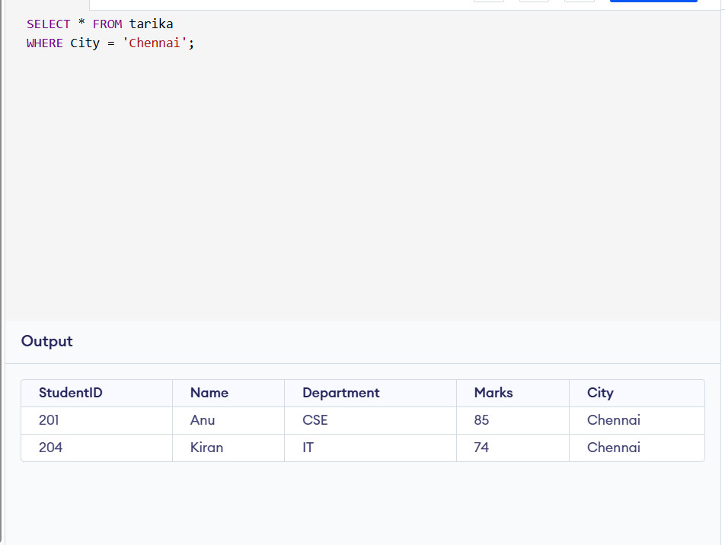
- Write a query to display students whose marks are between 70 and 90.
SELECT * FROM Sabithasri
WHERE Marks BETWEEN 70 AND 90;
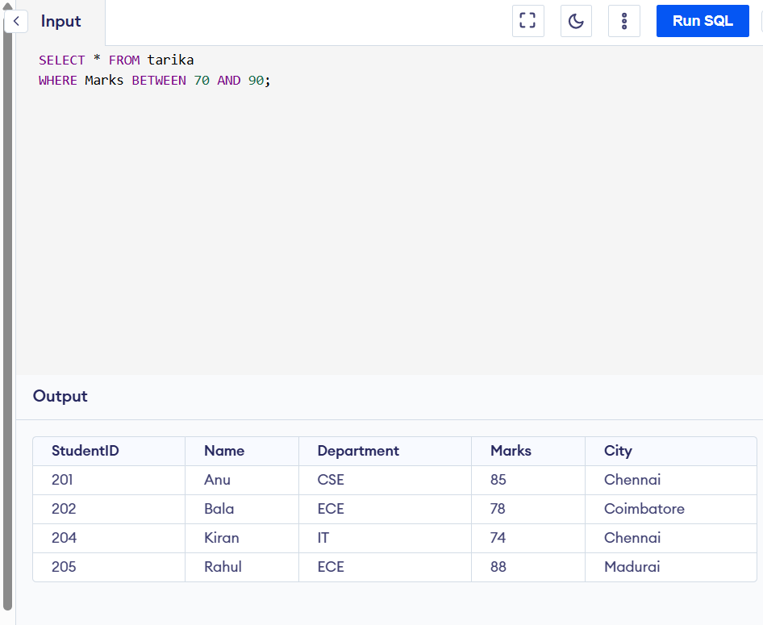
- Write a query to display student names that end with the letter ‘a’ using the LIKE operator.
SELECT * FROM Sabithasri
WHERE Name LIKE '%a';
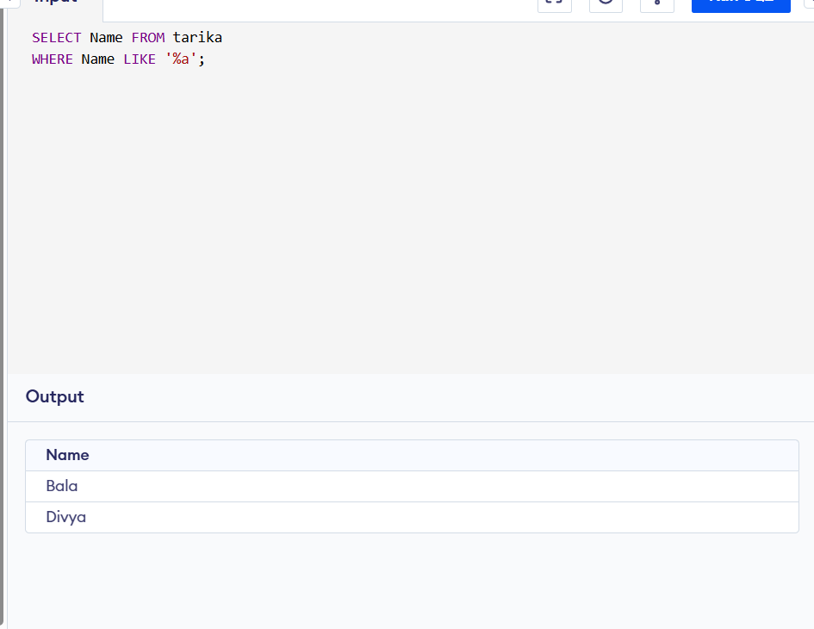
- Write a query to display distinct departments from the Student table.
SELECT DISTINCT Department
FROM Sabithasri;
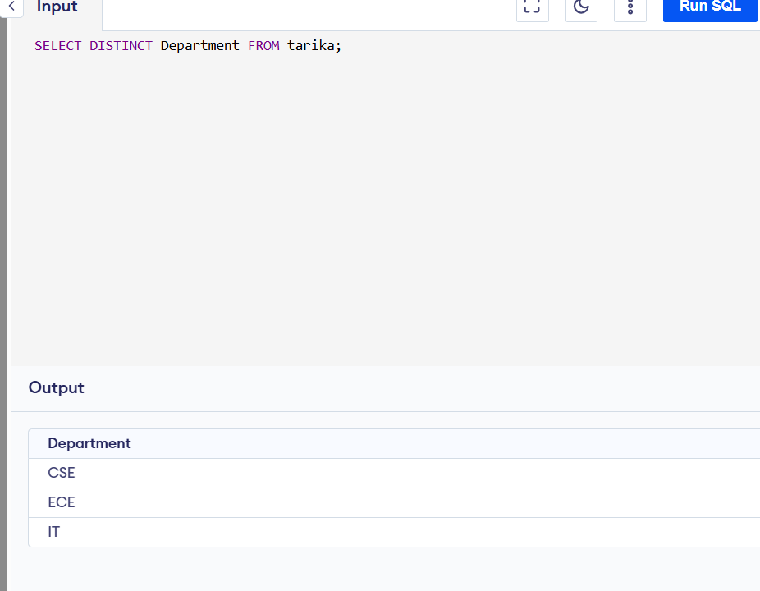
- Write a query to display students whose City value is NULL.
SELECT * FROM Sabithasri
WHERE City IS NULL;
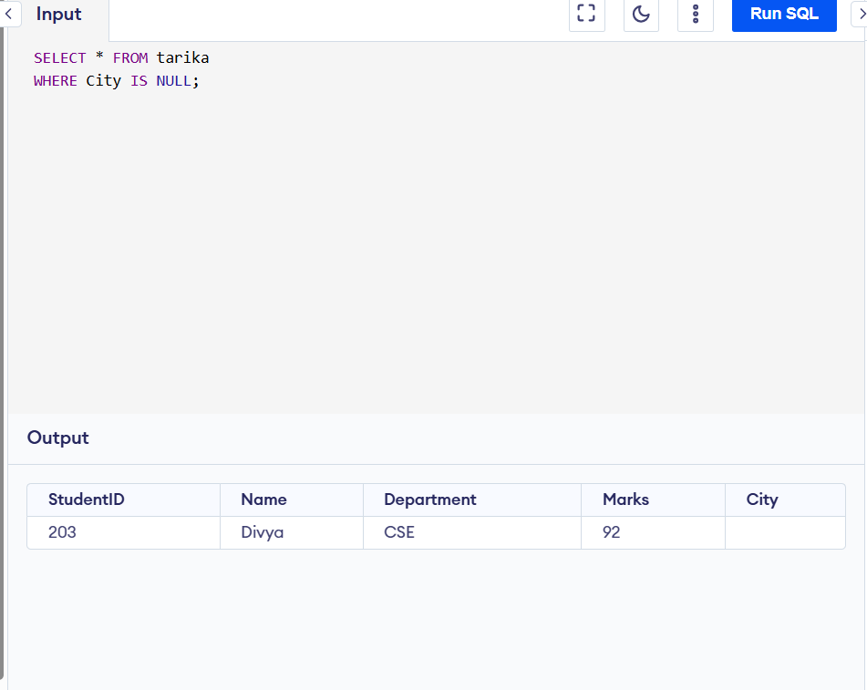
- Write a query to find the highest marks obtained by a student using an aggregate function.
SELECT MAX(Marks) AS HighestMarks
FROM Sabithasri;
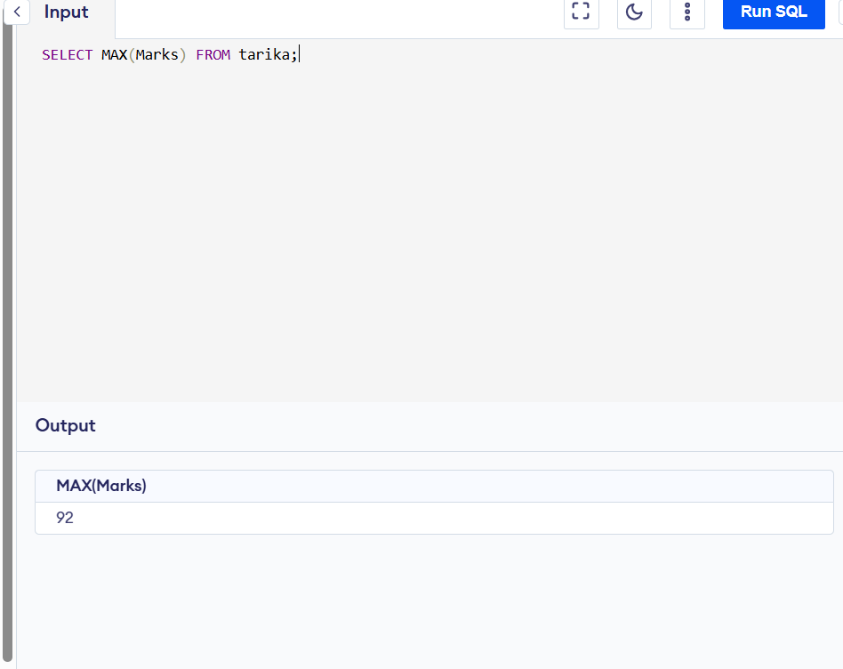

Write a query to find the average marks of students in the ECE department.
SELECT AVG(Marks) AS AverageMarks
FROM Sabithasri
WHERE Department = 'ECE’;
bg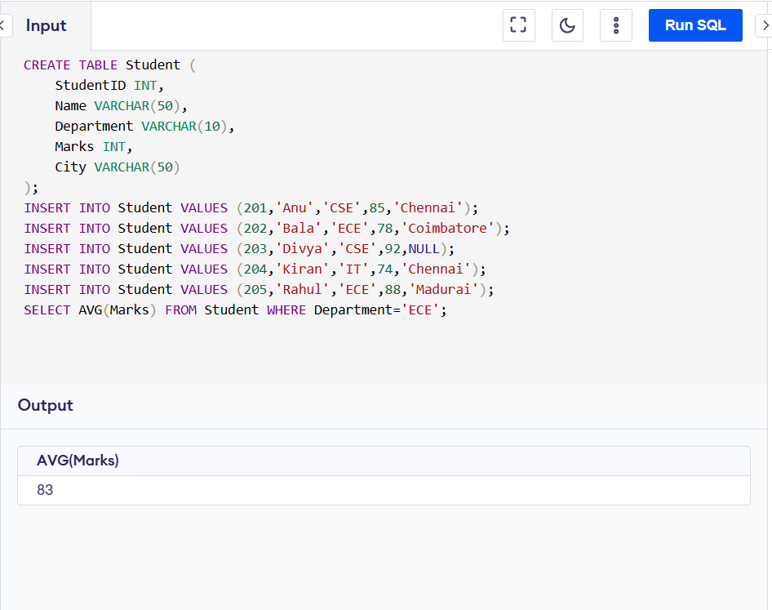
- Write a query to count the number of students in each department using GROUP BY.
SELECT Department, COUNT(*) AS StudentCount
FROM Sabithasri
GROUP BY Department;
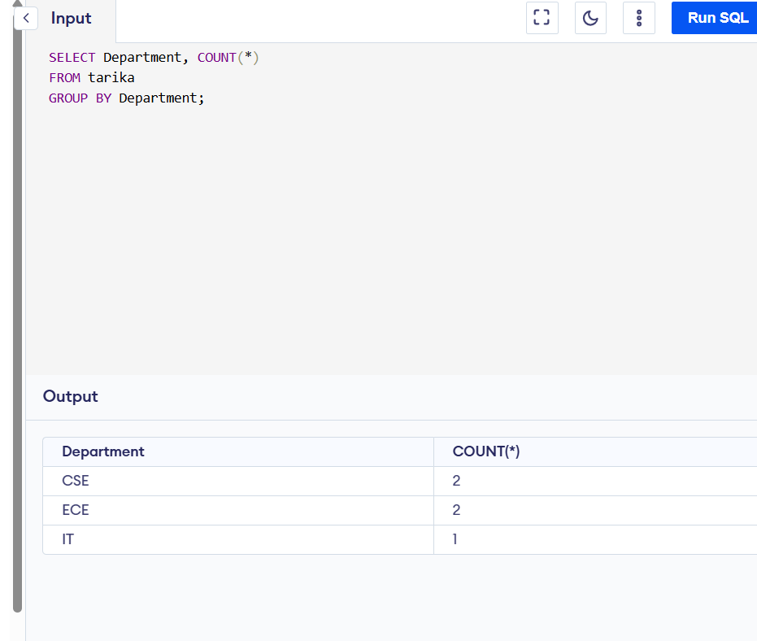
- Write a query to display students whose marks are greater than the average marks of all students (nested subquery).
SELECT * FROM Sabithasri WHERE Marks > (
SELECT AVG(Marks) FROM Sabithasri);
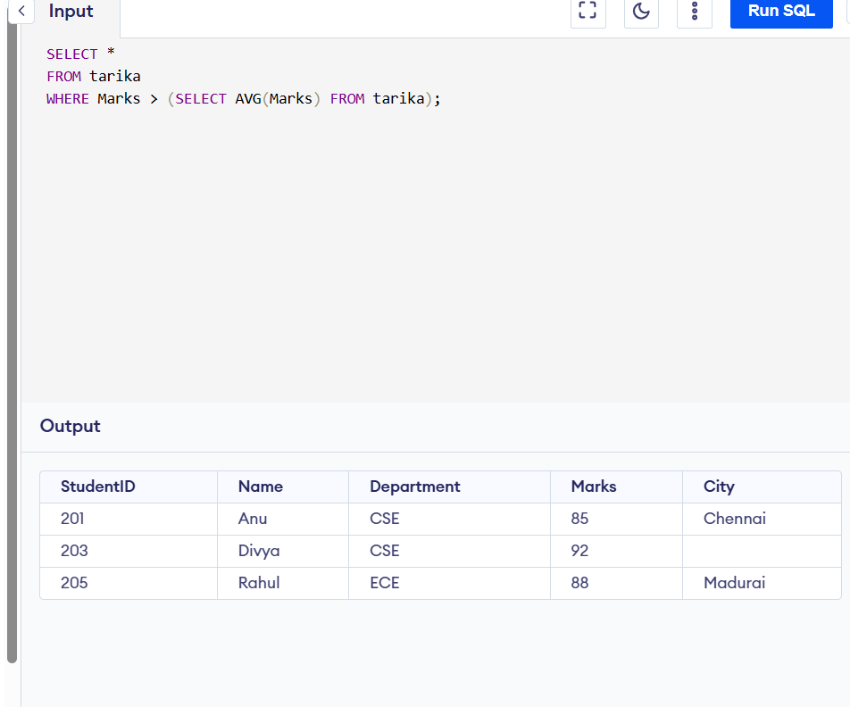

Write an SQL statement to insert a new student record into the Student table.
INSERT INTO Sabithasri VALUES (206,'Meena','CSE',81,'Salem');
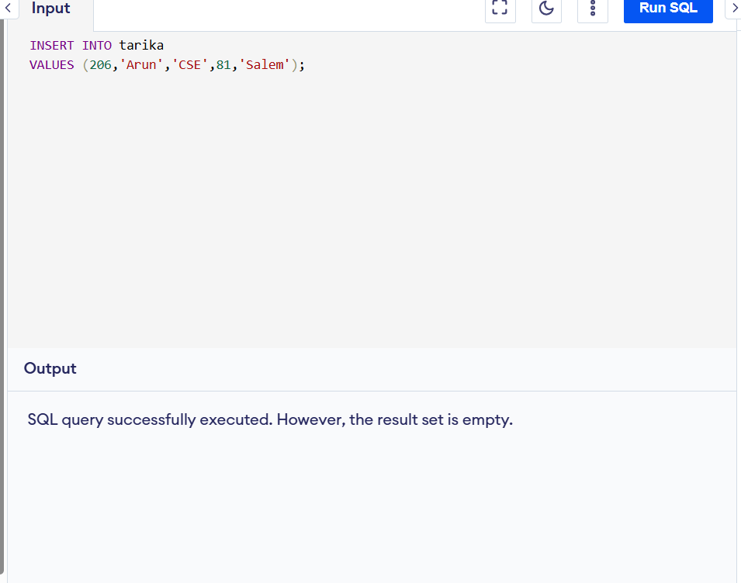
- Write an SQL query to delete the student with StudentID = 205.
DELETE FROM Sabithasri WHERE StudentID = 205;
